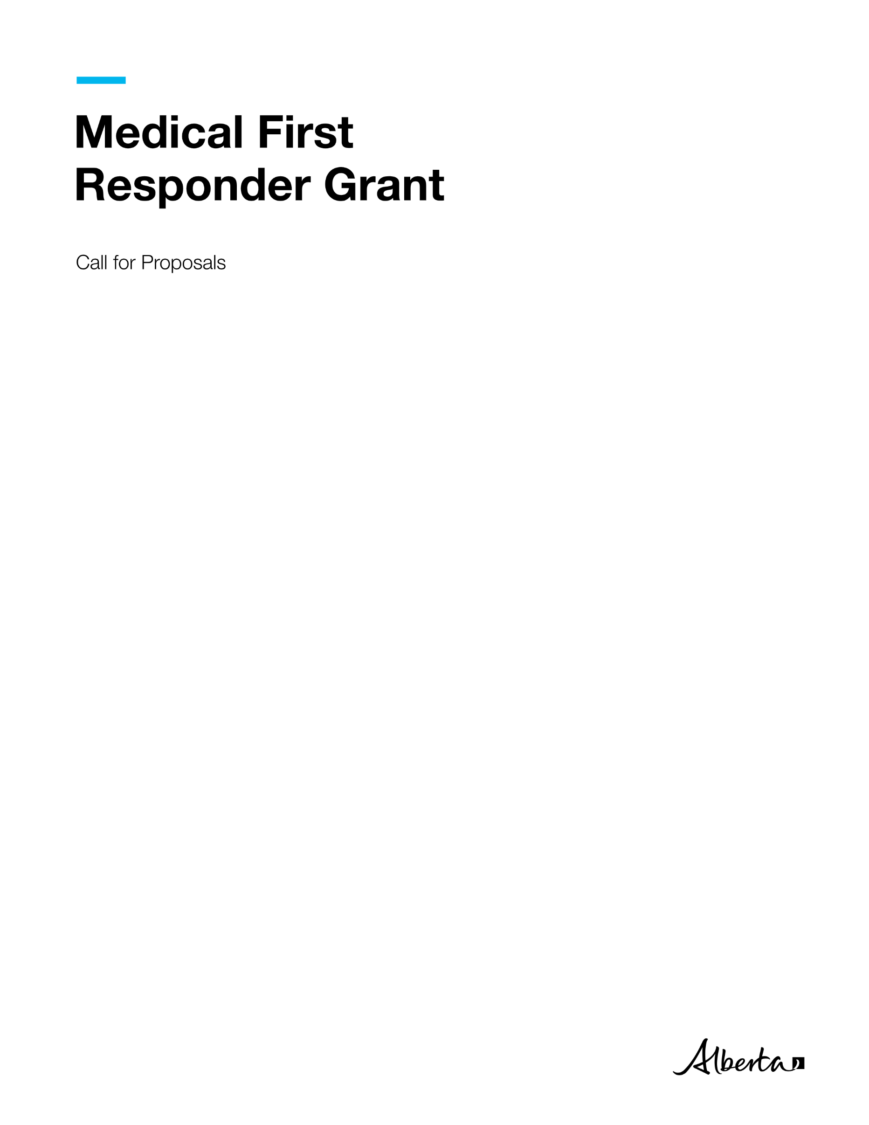

Medical First Responder Grant | Health

© 2024 Government of Alberta | October 3, 2024



###### Contents

Call for Proposals 1

Medical First Responder Grant Application 1

Project Description 1

Purpose 1

Service 1

Rationale 2

Who can apply 2

Eligibility Criteria 2

Application Process 2

Evaluation and Approval Process 2

Timeline 2

Proposal Coversheet 4

Grant Applicant Information 4

Project Information 5

Proposal Template 6

Project Plan 9

Budget Worksheets 10

Financial Statement 11

Proposal Evaluation Considerations 12

Expense Guidelines 13

Grant Proposal Checklist 14



# Call for Proposals

## Medical First Responder Grant Application

The information you provide on and with this application is collected and used pursuant to section 33(c) of the Freedom of Information and Protection of Privacy Act (FOIP ACT). The information you provide will be used by Alberta Health for the purposes of processing your application for the Medical First Response (MFR) Grant. The information collected will be managed in accordance with FOIP. If you have any questions about the collection, use or disclosure of this information, contact the Emergency Health Services (EHS) Branch by email at EHSgrant@gov.ab.ca.

The Government of Alberta is providing one-time funding of up to $50,000 to support rural and remote communities, as well as First Nations, Métis and Inuit communities (including First Nations, Tribal Councils and Treaty Organizations, Metis Settlements General Council, Metis Settlements, Métis Nation of Alberta, and Indigenous-serving non-profit organizations) that would like to establish a Medical First Response (MFR) program within their community. The grant is intended to assist communities in the development of MFR response capacity in their communities. The grant could assist in the purchase of new equipment, training for staff and volunteers, and other eligible supports. The MFR Program is provided primarily by municipal fire rescue agencies or local community groups, allowing for quick response to emergencies and delivery of patient care until Emergency Medical Services (EMS) can arrive.

Please submit a funding proposal to EHSgrants@gov.ab.ca. Applicants must be legal entities (for example, a company/organization or a municipality). Please complete the grant application and proposal by clearly defining the scope of work, detailed breakdown of project costs and a reasonable timeline for achieving project milestones. For assistance in completing this grant application, please contact the EHS Branch at [EHSgrants@gov.ab.ca](mailto:EHSgrants@gov.ab.ca).

### Project Description

The MFR Grant will provide one-time funding to develop a new MFR program to build community capacity to effectively respond to medical emergencies in rural, remote, as well as First Nations, Métis and Inuit communities. The funding contributes to strengthening the overall emergency medical system and overall provincial MFR capacity.

### Purpose

The Grants will support communities in rural, remote, as well as First Nations, Métis and Inuit communities who would like to establish an MFR capability within their community. The purpose of this grant is to provide funding to these communities to develop a new MFR response capability.

### Service

The Grants will fund communities interested in establishing a new MFR program. Up to $50,000 is available to each recipient agencies or community. The total value of the grant is up to $800,000. The funding will assist in purchasing new equipment, providing training for staff and/or volunteers, and other eligible supports.

### Rationale

Reducing EMS response times and enhancing access to care in rural areas is a government priority and this funding will help strengthen the efficiency of pre-hospital care along the continuum. These grants will also enable the provincial health workforce strategy in that MFR agencies are often pre-cursor pathways that attract first responders into the paramedic profession and support their career development by enabling them to train and remain in their local communities.

### Who can apply

Municipalities, rural and remote communities, as well as First Nations, Métis and Inuit communities (including First Nations, Tribal Councils and Treaty Organizations, Metis Settlements General Council, Metis Settlements, Métis Nation of Alberta, and Indigenous-serving non-profit organizations) who meet the eligibility criteria can apply for this grant.

### Eligibility Criteria

* Communities that do not currently have an MFR program.
* Communities with less than 3000 Alberta residents.
* Ability and willingness to participate in the Alberta Health Services (AHS) MFR program (<https://www.albertamfr.ca>). Participation in this program is a grant requirement.

### Application Process

Applicants will have 4 weeks to develop and submit their completed funding proposal including pages 5 to 11, as well as page 14.

### Evaluation and Approval Process

The applications will be reviewed by the Government of Alberta EHS Branch, within 4 weeks of closing. Funding will be distributed geographically across the province taking into consideration location and distance from local EMS and population. Once applications are reviewed and decisions are finalized, the funding will be awarded to the successful applicants.

### Timeline

|  |  |  |
| --- | --- | --- |
| **Activity** | **Timeline** | **Notes/Templates/Contacts** |
| Submit grant proposal | October 8, 2024, to November 5, 2024 (4 weeks) | Email the grant proposal to [EHSgrants@gov.ab.ca](mailto:EHSgrants@gov.ab.ca). |
| Review grant proposal | November 6, 2024, to December 4, 2024 (4 weeks) | Alberta Health reviews applicant grant proposals. |
| Announce grant recipients | December 5, 2024, to December 12, 2024 (1 week) | Successful applicants will be notified. |
| Project development | December 13, 2024, to February 14, 2025 (9 weeks) | Project scope and deliverables are finalized, and the grant agreement is emailed to the grant recipient. |
| Finalize grant funding agreement | February 17, 2025, to March 3, 2025 (2 weeks) | Grant agreement is signed by grant recipient and Alberta Health for execution. |
| Award grant funding | March 4, 2025, to March 18, 2025 (2 weeks) | Grant payment is sent to grant recipient. |

# Proposal Coversheet

Medical First Responder Grant March 1, 2025, to March 31, 2026

Submit an electronic copy of the proposal to[**EHSGrants@gov.ab.ca**](mailto:EHSGrants@gov.ab.ca)by 4:30 PM by November 5, 2024.

## Grant Applicant Information

**Incorporated Legal Name of Operator and/or Community; or Name of Business or Organization:**

**Mailing Address (All correspondence will be sent here):**

**Project Contact Name:**

**Phone number: Email Address:**

**Authorized Signatory:**

**Last Name: First Name:**

**Title: Email Address:**

**Phone Number: Alternate Phone Number:**

**Project Information**

**Project Name:**

**Start Date: End Date:**

**Type of Organization (please select one):**

Incorporated non-profit organization

Rural and/or Remote Community

Municipality

First Nation/ Metis Settlement

Other (please specify):

**Is this a collaboration between multiple groups or organizations?**

Yes  No

If yes, please list groups/organizations below and ensure completion of the Budget Worksheet - Breakdown by Collaborator:

# Project Information

**Total amount of funding requested:**

**Location to be served through this funding:**

# Proposal Template

Project Summary: *Please provide a brief overview of the purpose and scope of the proposed project. Please provide a clear and concise explanation of the project including what the project is, why you propose to do it, the scope of the work that will be done and how it will strengthen and stabilize the paramedic workforce in remote, rural, as well as First Nations, Métis and Inuit communities in Alberta.*

*Explain how the project for which you are seeking funding will address anticipated community needs.*

*Explain if there is expectation of future reliance on federal or provincial funding to maintain the project beyond one year.*

Organizational history: *Include a brief explanation of how the organization was established, its mission, vision and structure, as well as its record of working on related initiatives. Attach a current, dated organizational chart that demonstrates how the proposed project fits into the agency structure. (Max 300 words)*

Organizational Capacity:  *Briefly describe your organization’s capacity to quickly initiate and develop a new MFR program.* *Additionally, describe how the project activities will be unique and exclusive from existing programs and how the project will be completed by the end of the grant term. (Max 500 words)*

Project Intent and Evidence of Need**:** *Provide detail regarding how this project will meet the needs of rural, remote, as well as First Nations, Métis and Inuit communities who lack emergency service capabilities and experience lengthy EMS response times. Identify the main issues of focus and the outcomes the project will achieve. Please describe or illustrate the timelines and project milestones and link the timeline to operational objectives and project outcomes. (Max 300 words)*

Project Scope**:** *In point form, summarize the work the project will deliver as well as activities that are not possible within the confines or scope of project.*

|  |  |
| --- | --- |
| **In Scope** | **Out of Scope** |
|  |  |
|  |  |
|  |  |
|  |  |
|  |  |
|  |  |
|  |  |

**Constraints -***Describe any limitations that may have an impact on the project. (Max 200 words)*

Risk Assessment **-** *Identify the risks that could influence the project/program’s success, including those related to scope (purpose/objectives), cost (budget), or schedule. Assess the risks as High, Moderate or Low and describe mitigating strategies.*

|  |  |  |  |
| --- | --- | --- | --- |
| **Risk** | **Probability** | **Impact** | **Response Strategy** |
| ***What is the name of the Risk?*** | ***Is this risk High, Moderate, or Low?*** | ***If it happens, what effect will it have?*** | ***How will you deal with the risk?*** |
|  |  |  |  |
|  |  |  |  |
|  |  |  |  |
|  |  |  |  |

Stakeholder Engagement:*How will stakeholders (clients, supporters, collaborators, and community members) be engaged in the project? (Organizations are encouraged to consider ways to engage with local community members, groups, and business owners throughout the project.) (Max 300 words)*

Knowledge Mobilization**:** *Describe the project’s potential impact for all Albertans through knowledge transfer and exchange****.*** *(Max 300 words)*

Sustainability/Legacy Planning**:** *How will the project be concluded by the end of the grant term? Describe what (if anything) will continue or exist as a resource after the funding has ended. (Max 300 words)*

# Project Plan

Provide *a high-level overview of project objectives, the planned actions and activities that will support the project objectives and which grant priority they address. Objectives should relate to one or more grant priorities and should be specific, measurable, attainable, realistic, and timely (SMART).*

|  |  |  |  |  |  |
| --- | --- | --- | --- | --- | --- |
| *Program Objective:* |  | | | | |
| *Activity* | *Priority Population* | *Outputs* | *Expected Outcome* | Performance Indicator(s)  (How will you measure achievement of outcome) | *Grant Priority Addressed* |
|  |  |  |  |  |  |
|  |  |  |  |  |  |
| *Program Objective:* |  | | | | |
| *Activity* | *Target/Priority Population* | *Outputs* | *Expected Outcome* | Performance Indicator(s) | *Grant Priority Addressed* |
|  |  |  |  |  |  |
|  |  |  |  |  |  |

**Organizations can submit the program project plan using this template or their own document as long as the above information is provided.**

# Budget Worksheets

Please use the categories listed below and ensure both a breakdown by expense and by collaborator (if applicable) is provided. Expense guidelines are provided after the table. An Excel template has been provided in this proposal package.

|  |  |  |  |
| --- | --- | --- | --- |
| **Organization**  (Name of applicant or organization collaborator that will provide services) | **Project allocation**  (Amount from proposed budget that will be used by this organization) | **Services Provided**  (Service delivered and the priority population targeted) | **Priority Population** |
|  | $ |  |  |
|  | $ |  |  |
|  | $ |  |  |
|  | $ |  |  |
|  | $ |  |  |

**Requested One-Time Funding: __________________**

**Breakdown by Collaborator** (Only applicable to applications by community collaborations)

**Financial Sources**

List all of the projected financial sources of the project.

|  |  |  |  |
| --- | --- | --- | --- |
| **Other Sources of Funding** | **Name of Institution/Funding Type** | **Type of Financing/Description** | **Funding Amount** |
| **Financial Institution** |  |  |  |
| **Other Grants** |  |  |  |
| **Company/Community Funds** |  |  |  |
| **In-kind support for project and approximate value** |  |  |  |

# Financial Statement

|  |  |  |  |
| --- | --- | --- | --- |
| **Expenses** | **Description/ Comments** | **January 1, 2025 - March 31, 2025** | **April 1, 2025 - March 31, 2026** |
| Recruitment | | |  |
|  |  | $ |  |
|  |  | $ |  |
| Project Materials and Supplies | | |  |
| Printing/  Photocopying |  | $ |  |
| Project supplies |  | $ |  |
| Client supplies |  | $ |  |
| Other (specify) |  | $ |  |
| Eligible Equipment (program specific equipment - please specify) | | |  |
|  |  | $ |  |
|  |  | $ |  |
| Training | | |  |
| Courses/Education |  | $ |  |
| Meetings/Events |  | $ |  |
| Travel |  | $ |  |
| Other (Specify) |  | $ |  |
| Total Expenses |  | $ |  |

Reporting  
Recipients must regularly report on the project’s financial status and outcomes achieved. If the project scope or deliverables change after the Grant Agreement is in place, the recipient must contact EHSgrants@gov.ab.ca. Both parties must agree to amend the Grant Agreement to accommodate the changes.

# Proposal Evaluation Considerations

Proposals that meet mandatory requirements will be evaluated based on, but not limited to, the following considerations:

#### Impact

* Proposal aligns with funding priorities targeting rural, remote, as well as First Nations, Métis and Inuit communities.
* Proposal clearly describes the purpose and scope of project and rationale for how proposed activities will address identified needs.
* Proposal provides evidence showing that the desired impact will successfully be facilitated through the suggested activities.
* Proposal explains how the project will strengthen and stabilize the paramedic workforce in remote, rural, and Indigenous communities in Alberta.

#### Demonstrated Need/ Feasibility

* Applicant provides information on how the community is being impacted by lack of emergency service capabilities and lengthy EMS response times and challenges being experienced among rural, remote, as well as First Nations, Métis and Inuit communities, specific to the proposed project location.
* Proposal and work plan clearly present activities to be undertaken, how goals will be achieved, and the likelihood that the proposed project will achieve its goals or targets in the funding period.
* Activities and services are feasible to implement in the service area context.
* Proposed project complements (or enhances) rather than duplicates existing activities for the population(s) in the service area.

#### Organizational and Financial Capacity

* Organization (and collaborators if applicable) demonstrates the required expertise and resources to deliver outcomes on time and on budget.
* Applicant demonstrates strong financial and management systems.
* Proposal demonstrates the project is cost-effective in delivering outcomes.
* Proposed budget meets proposal requirements and provides clear rationale for allocations.

# Expense Guidelines

A Grant Recipient may only use grant funding as set out in the grant agreement for expenses that are directly related to the project activities. If a Grant Recipient is uncertain if a proposed expenditure is an eligible or ineligible expense, they should contact the Alberta Health grant manager prior to making the expenditure.

Eligible expenses include equipment, education, and recruitment. Non-eligible expenses include staff wages, renovations, vehicles, land and property, infrastructure, and administration fees.

* Compensation related expenses - Expenses must be for individuals whose duties are directly and primarily related to activities undertaken as part of the project as set out in the grant agreement. Ineligible items include, but are not limited to:
  + Discretionary severance and separation packages.
* Travel and subsistence costs - Travel and subsistence costs include reasonable out-of-pocket expenses in accordance with standard Government of Alberta rates for fieldwork, research, and other activities directly related to and necessary to carry out the activities under the project as set out in the grant agreement. Travel and subsistence costs must comply with and must not exceed the maximum allowable under the directive applicable to Government of Alberta employees. Ineligible items include, but are not limited to:
  + Commuting costs between residence and place of employment.
  + Passport and immigration fees.
  + Reimbursement for airfare purchased with personal frequent flyer points.

# Grant Proposal Checklist

All applications and proposals must include:

* Completed and signed grant application and grant proposal, including pages 5 to 11, and page 14.
* Evidence of authority to act on behalf of the community and a letter of intent/commitment to participate in the Alberta Health Services MFR Program.
* All documents must be submitted together as one digital copy.

**Declaration**

This application must be signed by an authorized representative with full legal authority. The application must be signed and dated before Alberta Health receives the application and grant proposal package.

* I understand that information in the application form, may be disclosed/shared with other funders such as government departments, agencies and private sector organizations, as required.
* The organization I represent endorses the project.
* As the authorized representative of this community, I confirm that I have reviewed and understand the guidelines of submission for this grant program. I attest that all the information provided in this application is accurate and true to the best of my knowledge.

I, ______________________ (name in full), of the community of ____________, in the Province of Alberta, am the ___________________ (insert position) of _______________ (name of applicant organization).

I hereby certify that I represent the governing body of the applicant organization and am authorized to sign this Grant Application and Proposal Submission.

________________________ ___________________ ____________

Authorized Signing Officer Signature Date