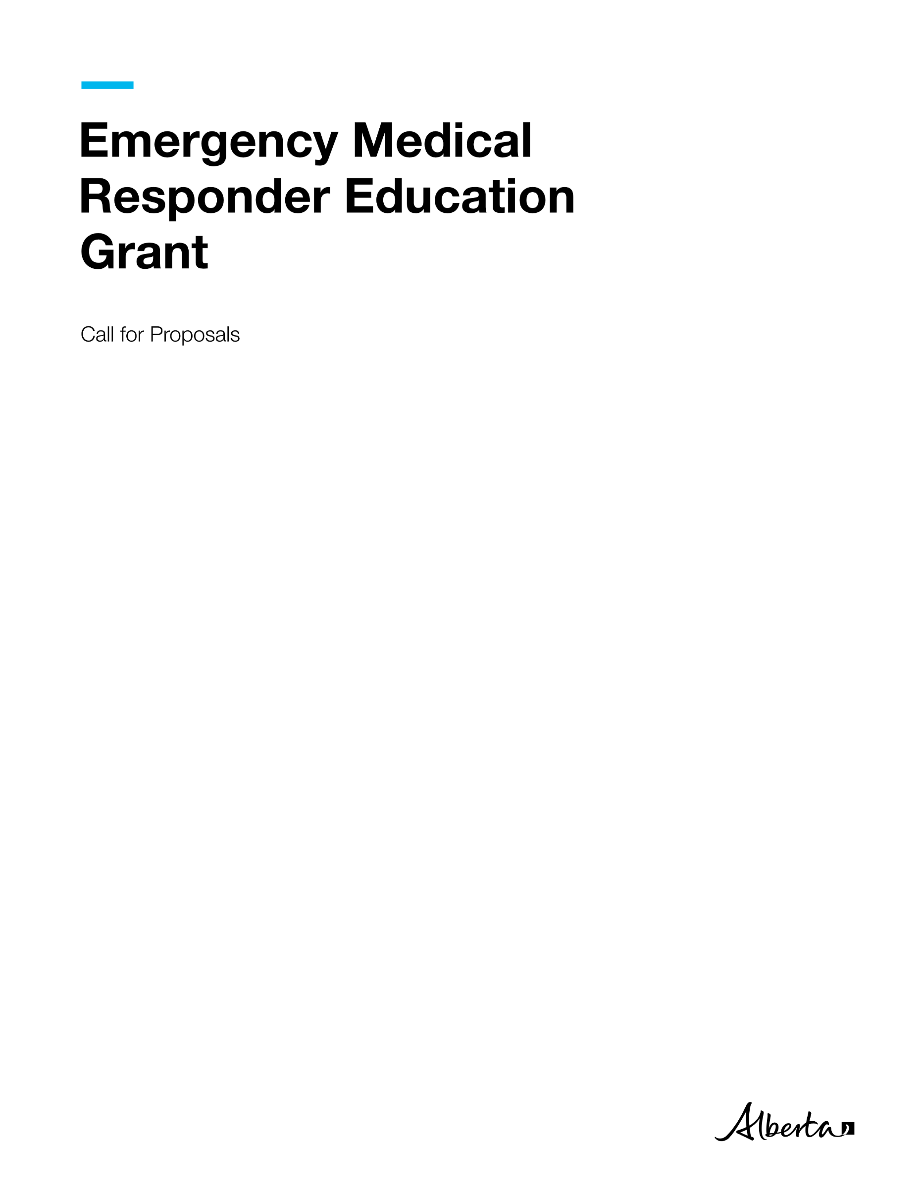

Emergency Medical Responder Education Grant | Health

© 2024 Government of Alberta | October 2, 2024



###### Contents

Call for Proposals 1

Emergency Medical Responder Education Grant Application 1

Project Description 1

Purpose 1

Service 2

Rationale 2

Eligibility Criteria: 2

Application Process 2

Evaluation Process 2

Timeline 3

Proposal Coversheet 4

Grant Applicant Information 4

Proposal Template 5

Project Plan 7

Budget Worksheets 8

Financial Statement 9

Proposal Evaluation Considerations 10

Expense Guidelines 11

Grant Application and Grant Proposal Checklist 12



# Call for Proposals

## Emergency Medical Responder Education Grant Application

The information you provide on and with this application form is collected and used pursuant to section 33(c) of the Freedom of Information and Protection of Privacy Act (FOIP Act). The information you provide will be used by Alberta Health for the purposes of processing your application for the Emergency Medical Responder (EMR) Education Grant. The information collected will be managed in accordance with FOIP. If you have any questions about the collection, use or disclosure of this information contact the Emergency Health Services (EHS) Branch by email at EHSgrants@gov.ab.ca.

The EMR Education Grant will provide up to $24,000 in funding for EMR training to organizations located in communities with existing or nearby Emergency Medical Services (EMS) stations. The intent of the grant is to increase EMS practitioners in rural and remote communities, as well as First Nations, Métis and Inuit communities. The grants will facilitate the attraction, training, and retention of paramedics in their local communities. The goal is to strengthen the overall paramedic workforce in Alberta, improve ambulance response times, and assist local community members interested in supporting their community through training and certification as EMR’s. EMR’s are an entry level paramedic, regulated by the Alberta College of Paramedics (ACP). EMR’s provide emergency care for patients, often in rural and industrial areas.

Licensed private or contracted ambulance operators that service rural and remote communities, as well as First Nations, Métis, and Inuit communities, and Indigenous-serving organizations, have four weeks to develop and submit a funding proposal using the grant application and proposal form to EHSgrants@gov.ab.ca. Those applying must be legal entities. The proposal must be fully completed by clearly defining the scope of work, including a detailed breakdown of projected costs and providing a reasonable timeline for completing the project activities and reaching project milestones. For assistance in completing this grant application, contact the EHS Branch at [EHSgrants@gov.ab.ca](mailto:EHSgrants@gov.ab.ca).

### Project Description

The EMR Education Grant will provide EMR training opportunities for individuals through agencies based in rural, remote, First Nations, Métis and Inuit communities in Alberta. A total of $24,000 is available for approved eligible organizations to assist local residents interested in joining the EMS workforce, through obtaining their EMR certification.

### Purpose

The Grants will support the provincial health workforce strategy through aiming to attract and retain new in- community practitioners to strengthen and stabilize the EMS workforce in rural, remote, First Nations, Métis, and Inuit communities. An improved EMS workforce will enable key priorities to be actioned, such as improving ambulance response times, while supporting the implementation of key recommendations aimed at improving and supporting community EMS response from the Alberta EMS Provincial Advisory Committee (AEPAC) and Dispatch Review Reports.

### Service

The Grants will fund organizations or agencies that express interest in recruiting individuals for in-community training programs that will qualify them to practice as EMRs. Focus will be placed on rural, remote, First Nations, Métis and Inuit communities in Alberta experiencing challenges in attracting and retaining EMS staff. The grants will be used to fund EMR courses, delivered by post-secondary institutions approved by the ACP, offering a combination of virtual and in-person training within successful grant recipient communities. Funding may also be used to cover the cost of regulatory college exam fees for participants, but does not include capital expenses, operational and existing costs.

### Rationale

Ambulance operators that serve rural, remote, First Nations, Métis and Inuit communities are experiencing challenges in staffing ambulances. In many areas, Alberta vacancy rates exceed 30 per cent, leading to longer EMS response times and decreased ambulance availability. The EMR Education Grant is specifically intended to bring community residents into the EMS profession and support their career development by enabling them to train and remain in their communities. This aims to increase access to health care services for Albertans by improving EMS system capacity.

### Eligibility Criteria:

Eligibility is limited to organizations that serve residents of Alberta, specifically:

* Rural communities
* Remote communities
* First Nations
* Tribal Councils and Treaty Organizations
* Metis Settlements General Council
* Metis Settlements
* Métis Nation of Alberta
* Indigenous serving non-for-profit organization.
* Licensed private or contracted ambulance operator in a rural, remote, First Nations, Métis and Inuit communities.

Applicants must:

* Demonstrate or identify difficulty in attracting or keeping EMS practitioners.
* Ability to host in-house and virtual components of the training program.
* Letter of commitment to partner with a post-secondary institution or EMR training provider, approved by the ACP, to provide EMR training.

### Application Process

* Applicants will have 4 weeks to develop and submit their completed funding proposal including pages 5 to 10, and page 13.

### Evaluation Process

The applications will be reviewed by the Government of Alberta’s EHS Branch, within 4 weeks of closing. Funding will be distributed geographically across the province. Identified communities who have demonstrated inability to attract and retain qualified practitioners in their community will take priority with the intent of equitable geographical distribution across the province. Once applications are reviewed and decisions are finalized, the funding will be awarded to the successful applicants.

### Timeline

|  |  |  |
| --- | --- | --- |
| **Activity** | **Timeline** | **Notes/Templates/Contacts** |
| Request grant funding | October 8 to November 5, 2024 (4 weeks) | Email the grant proposal to [EHSgrants@gov.ab.ca](mailto:EHSgrants@gov.ab.ca) |
| Review grant proposals | November 6 to December 4, 2024 (4 weeks) | Alberta Health reviews grant proposals. |
| Notify grant recipients | December 5-12, 2024  (1 week) | Successful applicants will be notified. |
| Develop Project | December 13, 2024 to February 7, 2025 (8 weeks) | Project scope and deliverables finalized. |
| Execute grant funding agreement | February 10-24, 2025  (2 weeks) | Grant agreement signed by recipient and Alberta Health for execution. |
| Award grant funding | February 25 to March 11, 2025  (2 weeks) | Grant payment sent to grant recipient. |

# Proposal Coversheet

Emergency Medical Responder Education Grant March 31, 2025 to March 31, 2026

Submit an electronic copy of the proposal to EHSGrants@gov.ab.ca by 4:00 PM on November 5, 2024.

## Grant Applicant Information

**Incorporated Legal Name of Operator and/or Community; or Name of Business or Organization:**

**Mailing Address (All correspondence will be sent here):**

**Project Contact Name:**

**Phone number: Email Address:**

**Authorized Signatory**

**Last Name: First Name:**

**Title: Email Address:**

**Phone Number: Alternate Phone Number:**

**Project Information**

**Project Name:**

**Start Date: End Date:**

**Type of Organization (please select one):**

Incorporated non-profit organization

Rural and/or Remote Community

Municipality

First Nation/ Metis Settlement

Other (please specify):

**Is this a collaboration between multiple groups or organizations?**

Yes  No

If yes, please list groups/organizations below and ensure completion of the Budget Worksheet - Breakdown by Collaborator:

# Proposal Template

Project Summary: *Please provide a brief overview of the purpose and scope of the proposed project. Please provide a clear and concise explanation of the project including what the project is, why you propose to do it, the scope of the work that will be done and how it will strengthen and stabilize the local EMS workforce, improve ambulance response times, and enhance the overall capacity of the EMS system and increase access to healthcare services for Albertans, supporting important workforce improvements in Alberta’s EMS, in remote, rural, First Nation,* Métis, *Indigenous communities in Alberta.*

*Explain how the project for which you are seeking funding will address anticipated community needs.*

*Explain if there is expectation of future reliance on federal or provincial funding to maintain the project beyond one year.*

Organizational history: *Include a brief explanation of how the organization was established, its mission, vision and structure, as well as its record of working on related initiatives. Attach a current, dated organizational chart that demonstrates how the proposed project fits into the agency structure. (Max 300 words)*

Organizational Capacity:  *Briefly describe your organization’s capacity to quickly initiate and provide proposed EMR training to enhance your existing EMS service capacity or to coincide with development of a new Medical First Responder (MFR) agency.* *Additionally, describe how the project activities will be unique and exclusive from existing programs and how the project will be completed by the end of the grant term. (Max 500 words)*

Project Intent and Evidence of Need**:** *Provide detail regarding how this project will meet the needs of rural, remote, or Indigenous communities having difficulties attracting and/or retaining New Emergency Medical Responder (EMRs) in their community. Identify the main issues of focus and the outcomes the project will achieve. Please describe or illustrate the timelines and project milestones and link the timeline to operational objectives and project outcomes. (Max 300 words)*

Project Scope**:** *In point form, summarize the work the project will deliver as well as activities that are not possible within the confines or scope of project.*

|  |  |
| --- | --- |
| **In Scope** | **Out of Scope** |
|  |  |
|  |  |
|  |  |
|  |  |
|  |  |

**Constraints -***Describe any limitations that may have an impact on the project. (Max 200 words)*

Risk Assessment **-** *Identify the risks that could influence the project/program’s success, including those related to scope (purpose/objectives), cost (budget), or schedule. Assess the risks as High, Moderate or Low and describe mitigating strategies.*

|  |  |  |  |
| --- | --- | --- | --- |
| **Risk** | **Probability** | **Impact** | **Response Strategy** |
| ***What is the risk?*** | ***Is the risk High, Moderate or Low?*** | ***If it happens, what effect will it have?*** | ***How will you deal with the risk?*** |
|  |  |  |  |
|  |  |  |  |
|  |  |  |  |
|  |  |  |  |
|  |  |  |  |

Stakeholder Engagement**:** *How will stakeholders (clients, supporters, collaborators, and community members) be engaged in the project? (Organizations are encouraged to consider ways to engage with local community members, groups, and business owners throughout the project.) (Max 300 words)*

Knowledge Mobilization**:** *Describe the project’s potential impact for all Albertans through knowledge transfer and exchange****.*** *(Max 300 words)*

Sustainability/Legacy Planning**:** *How will the project be concluded by the end of the grant term? Describe what (if anything) will continue or exist as a resource after the funding has ended. (Max 300 words)*

# Project Plan

Provide *a high-level overview of project objectives, the planned actions and activities that will support the project objectives and which grant priority they address. Objectives should relate to one or more grant priority and should be specific, measurable, attainable, realistic, and timely (SMART).*

|  |  |  |  |  |  |
| --- | --- | --- | --- | --- | --- |
| *Program Objective:* |  | | | | |
| *Activity* | *Priority Population* | *Outputs* | *Expected Outcome* | Performance Indicator(s)  (How will you measure achievement of outcome) | *Grant Priority Addressed* |
|  |  |  |  |  |  |
|  |  |  |  |  |  |
| *Program Objective:* |  | | | | |
| *Activity* | *Target/Priority Population* | *Outputs* | *Expected Outcome* | Performance Indicator(s) | *Grant Priority Addressed* |
|  |  |  |  |  |  |
|  |  |  |  |  |  |

**Organizations can submit the program project plan using this template or their own document as long as the above information is provided.**

# Budget Worksheets

Please use the categories listed below and ensure both a breakdown by expense and by collaborator (if applicable) is provided. Expense guidelines are provided after the table. An Excel template has been provided.

|  |  |  |  |
| --- | --- | --- | --- |
| **Organization**  (Name of applicant or organization collaborator that will provide services) | **Project allocation**  (Amount from proposed budget that will be used by this organization) | **Services Provided**  (Service delivered and the priority population targeted) | **Priority Population** |
|  | $ |  |  |
|  | $ |  |  |
|  | $ |  |  |
|  | $ |  |  |

**Requested Funding: __________________**

**Breakdown by Collaborator** (Only applicable to applications by community collaborations)

**Financial Sources**

List all of the projected financial sources of the project.

|  |  |  |  |
| --- | --- | --- | --- |
| **Other Sources of Funding** | **Name of Institution/Funding Type** | **Type of Financing/Description** | **Funding Amount** |
| **Financial Institution** |  |  |  |
| **Other Grants** |  |  |  |
| **Company/Community Funds** |  |  |  |
| **In-kind support for project and approximate value** |  |  |  |

# Financial Statement

|  |  |  |  |  |
| --- | --- | --- | --- | --- |
| **Expenses** | **Description/ Comments** | **Jan. 1, 2025 - March 31, 2025** | **April 1, 2025- March 31, 2026** | **April 1, 2026- March 31, 2027** |
| Recruitment | | | | |
| Advertising |  | $ | $ | $ |
| Other (please specify) |  | $ | $ | $ |
| Project Materials and Supplies | | | | |
| Printing/  Photocopying |  | $ | $ | $ |
| Project supplies |  | $ | $ | $ |
| Client/Trainer supplies |  | $ | $ | $ |
| Other (specify)________ |  | $ | $ | $ |
| Travel | | | | |
| Transportation |  | $ | $ | $ |
| Accommodation |  | $ | $ | $ |
| Equipment (program specific equipment - please specify) | | | | |
| Van/ambulance rental |  | $ | $ | $ |
|  |  | $ | $ | $ |
| Training | | | | |
| Facility |  | $ | $ | $ |
| Trainer accommodations |  | $ | $ | $ |
|  |  | $ | $ | $ |
| Total Expenses |  | $ | $ | $ |

Reporting  
Recipients must regularly report on the project’s financial status and outcomes achieved. If the project scope or deliverables change after the Grant Agreement is in place, the recipient must contact EHSgrants@gov.ab.ca. Both parties must agree to amend the Grant Agreement to accommodate the changes.

# Proposal Evaluation Considerations

Proposals that meet mandatory requirements will be evaluated based on, but not limited to, the following considerations:

**Impact**

* Proposal aligns with funding priorities to provide EMR training opportunities through organizations based in rural, remote, and Indigenous communities to support staffing local EMS practitioners in their communities.
* Proposal clearly describes the purpose and scope of project and rationale for how proposed activities will address identified needs.
* Proposal provides evidence showing that the desired impact will successfully be facilitated through the suggested activities.
* Proposal explains how the project will strengthen the local EMS workforce, improve ambulance response times, and enhance the overall capacity of the EMS system and increase access to healthcare services for Albertans, supporting important workforce improvements in Alberta’s EMS.

**Demonstrated Need/ Feasibility**

* Applicant provides information on how the community is being impacted because EMS providers struggle to recruit and retain staff in rural, remote, and Indigenous communities, specific to the proposed project location.
* Proposal and work plan clearly present activities to be undertaken, how goals will be achieved, and the likelihood that the proposed project will achieve its goals or targets in the funding period.
* Activities and services are feasible to implement in the service area context.
* Proposed project complements (or enhances) rather than duplicates existing activities for the population(s) in the service area.

**Organizational and Financial Capacity**

* Organization (and collaborators if applicable) demonstrates the required expertise and resources to deliver outcomes on time and on budget.
* Applicant demonstrates strong financial and management systems.
* Proposal demonstrates the project is cost-effective in delivering outcomes.
* Proposed budget meets proposal requirements and provides clear rationale for allocations.

# Expense Guidelines

A Grant Recipient may only use grant funding as set out in the grant agreement for expenses that are directly related to the project activities. If a Grant Recipient is uncertain if a proposed expenditure is an eligible or ineligible expense, they should contact the EHS grant manager at [EHSgrants@gov.ab.ca](mailto:EHSgrants@gov.ab.ca) prior to making the expenditure.

Eligible expenses include Alberta College of Paramedics registration exam fees, education, and recruitment. Non-eligible expenses include administrative costs, planning and research, capital expenses, operational and existing expenses, and travel for Alberta College of Paramedics registration exam.

* Compensation related expenses - Expenses must be for individuals whose duties are directly and primarily related to activities undertaken as part of the project as set out in the grant agreement. Ineligible items include, but are not limited to:
  + Discretionary severance and separation packages.
* Travel and subsistence costs - Travel and subsistence costs include reasonable out-of-pocket expenses in accordance with standard Government of Alberta rates for fieldwork, research, and other activities directly related to and necessary to carry out the activities under the project as set out in the grant agreement. Travel and subsistence costs must comply with and must not exceed the maximums allowable under the directive applicable to Government of Alberta employees. Ineligible items include, but are not limited to:
  + Commuting costs between residence and place of employment.
  + Passport and immigration fees.
  + Reimbursement for airfare purchased with personal frequent flyer points.
* Equipment and supplies - Expenses include reasonable costs for the purchase of equipment and supplies, which are directly related to and will be used primarily for the project as set out in the grant agreement. Ineligible items include, but are not limited to:
  + Insurance costs for equipment.
  + Costs of construction, renovation of laboratories, offices.

# Grant Application and Grant Proposal Checklist

All applications must include:

* Completed and signed grant application and proposal including pages 5 to 10, and page 13.
* Evidence of authority to act on behalf of the community.
* Letter of commitment to partner with an Alberta College of Paramedics approved EMR training provider or post-secondary institution.
* All documents must be combined and submitted together – one in word format and one in PDF format.

**Declaration**

This application must be signed by an authorized representative with full legal authority. The application must be signed and dated before Alberta Health can receive the application and grant proposal package.

* I understand that information in the application form, may be disclosed/shared with other funders such as government departments, agencies and private sector organizations, as required.
* The organization I represent endorses the project.
* As the authorized representative of this community, I confirm that I have reviewed and understand the guidelines of submission for this grant program. I attest that all the information provided in this application is accurate and true to the best of my knowledge.

I, ______________________ (name in full), of the community of ____________, in the Province of Alberta, am the ___________________ (insert position) of _______________ (name of applicant organization).

I hereby certify that I represent the governing body of the applicant organization and am authorized to sign this Proposal Submission.

________________________ ___________________ ____________

Authorized Signing Officer Signature Date