Instructions: In preparation for the relocation, redeployment or demolition of your modular classroom(s), please provide the following information for each school site that is to receive new modular classrooms:

Core Information:
Name of School Board: | Select a School Board.
Name of School Board Contact: | Click here to enter text.
School Board Contact Phone No, Email Address: | Click here to enter text.
Name and Address of Donor School: | Click here to enter text.
Name and Address of Receiving School: | Click here to enter text.
Approximate Distance Between Schools: | Click here to enter text.
Total Number of Classroom(s) to be Moved or Demolished: | Click here to enter text.
Attaching to Existing Modular On Site: | Yes: ☐ |  |  | No: ☐
Connecting Link Required: | Yes: ☐ |  |  | No: ☐
Project Type: | Relocation: ☐ | Redeployment: ☐ |  |  | Demolition: ☐
Expected Completion Date: | Click here to enter a date.
Procurement Strategy: | Public Tender: ☐ |  | Own Forces: ☐

Important Notice: Prep Sheets must be submitted with a ” Expected Completion Date”. If Own Forces has been selected please see the Own Forces Responsibility Checklist below.

Please use the charts below to identify the number of modular classrooms of each type that are required to be Relocated/Redeployed/Demolished (See Page 4 for unit type/configuration reference)

T-Number | Manufacturer | Unit Type | Unit Configuration | Standard Duty or Heavy Duty
T-Number | Choose a Manufacturer. | Choose a Unit Type | Choose a Configuration. | Standard Duty or Heavy Duty
T-Number | Choose a Manufacturer. | Choose a Unit Type | Choose a Configuration. | Standard Duty or Heavy Duty
T-Number | Choose a Manufacturer. | Choose a Unit Type | Choose a Configuration. | Standard Duty or Heavy Duty
T-Number | Choose a Manufacturer. | Choose a Unit Type | Choose a Configuration. | Standard Duty or Heavy Duty
T-Number | Choose a Manufacturer. | Choose a Unit Type | Choose a Configuration. | Standard Duty or Heavy Duty
T-Number | Choose a Manufacturer. | Choose a Unit Type | Choose a Configuration. | Standard Duty or Heavy Duty
T-Number | Choose a Manufacturer. | Choose a Unit Type | Choose a Configuration. | Standard Duty or Heavy Duty
T-Number | Choose a Manufacturer. | Choose a Unit Type | Choose a Configuration. | Standard Duty or Heavy Duty

Site Plan:
A fully dimensioned site plan showing the location, orientation of the modular classrooms, and site access points for both the donor and receiving school(s). The site plan should clearly indicate the type of modular classroom that will be present (A-Unit, and/or B-Unit), along with their respective orientation.

Important Notice:
For all modular classrooms approved under the Modular Classroom Program (MCP), if the Modular Classroom Prep Sheet has not been received prior to March 31, 2024, your unit(s) are not guaranteed to be on site for the 2024/2025 School Year.

Please email a completed checklist along with the site plan to Alberta Infrastructure:
Modular Classroom Program – Infras.MCP@gov.ab.ca

Additional Considerations:
To best capture the estimated costs associated with site preparation, the following section has been added to answer common questions.

Manufacturing Clarifications:
- For units with the millwork sink option, there is no sump pump. System is gravity drained.
- General Contractor takes responsibility of modular classrooms during transportation. Any window damage or wall cracks that occur during transportation are the responsibility of the General Contractor.

Modular Classroom Program Clarifications:
- Unless identified on Form 9 – Modular Classroom Program Request and subsequently approved by Alberta Education, additional school modifications or improvements will not be supported by the Modular Classroom Program. (Ex. Parking Stalls, Additional Washrooms, Firewalls, etc.).
- Project Management fees are not supported.
- Costs incurred prior to approval from the Modular Classroom Program are not supported.

Cost Estimate: Only required to be completed for orders as part of The Modular Classroom Program (MCP). Please double click to enter information into the below excel table.

Own Forces Responsibility Checklist: Only to be completed and checked off by School Jurisdictions that elect to utilize The Own Forces delivery method (as per the School Capital Manual).
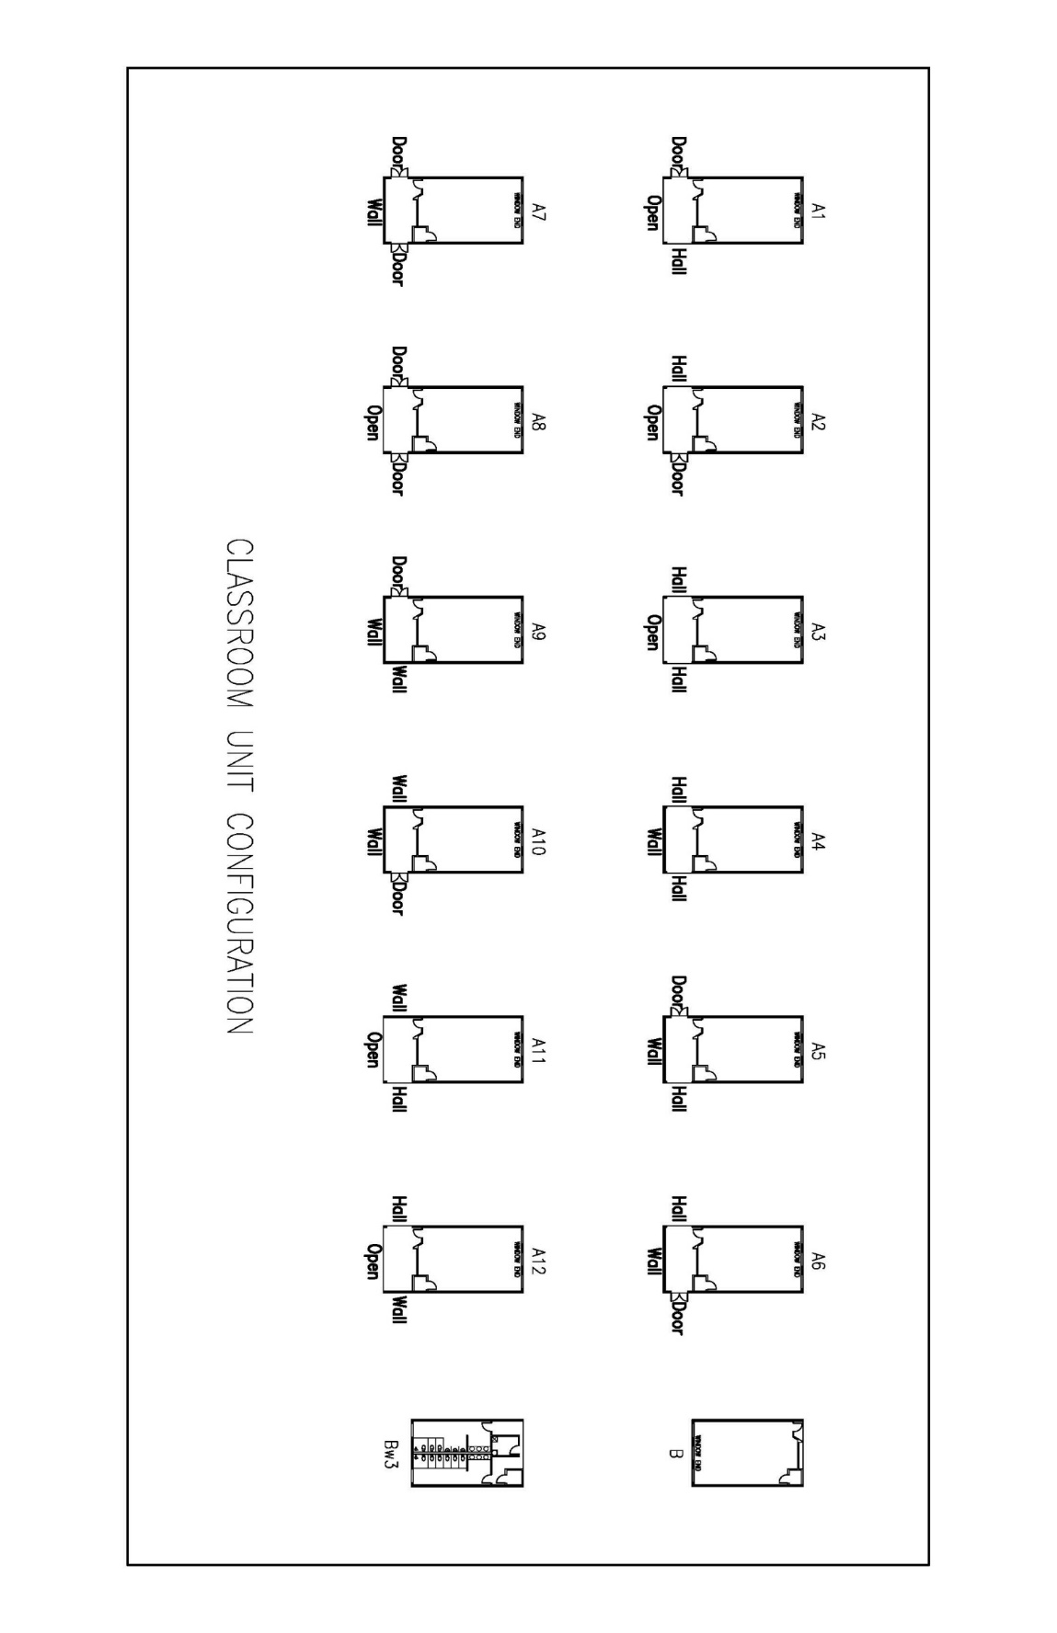
School Jurisdictions utilizing the Own Forces delivery method are responsible to:
☐ | - Acknowledge the risks and responsibilities to the school jurisdiction when acting as the prime contractor;  - Obtain and submit to Infrastructure confirmation of site and liability insurance for the project;  - Provide confirmation that appropriate permits have been or will be obtained; and  - Provide rationale to Infrastructure for the use of the Own Forces delivery method submitted with the completed prep sheet.

Classroom Unit Configuration:

